

Name –Chaitanya Nikam
PRN – 1262253562
Division – 13
Batch – M1
Course – FY B. Tech CSE CSF
Subject – Foundation of Programming

Assignment 1
Write a program in C to check leap year.

Program

#include <stdio.h>
int main() {
int year;
scanf("%d", &year);
if((year%4==0 && year%100!=0) || year%400==0)
printf("Leap Year");
else
printf("Not Leap Year");
return 0;
}

Output
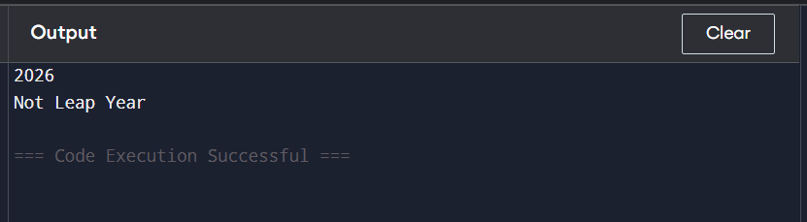

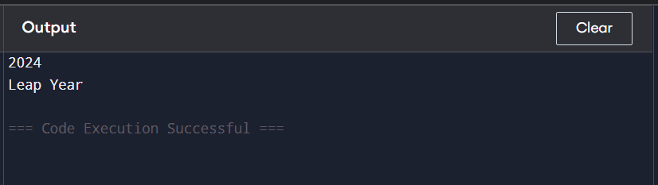

Assignment 2
Write a menu driven program in C to implement the basic arithmetic operations.

Program

#include <stdio.h>
int main() {
int ch;
float a,b;
scanf("%f%f",&a,&b);
printf("1.Add 2.Sub 3.Mul 4.Div\n");
scanf("%d",&ch);
switch(ch){
case 1: printf("%.2f",a+b); break;
case 2: printf("%.2f",a-b); break;
case 3: printf("%.2f",a*b); break;
case 4: printf("%.2f",a/b); break;
}
return 0;
}

Output
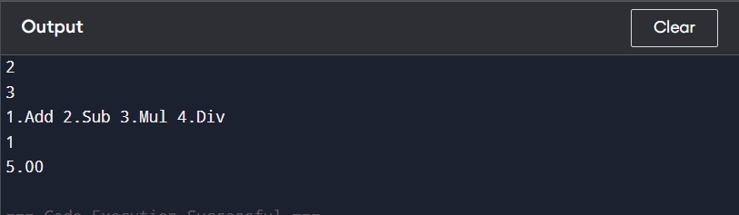
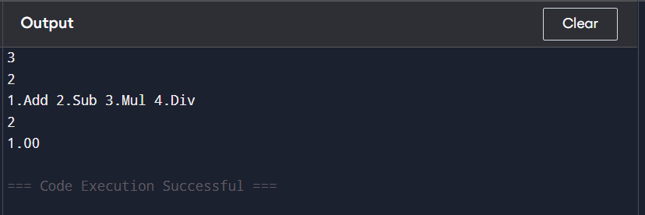

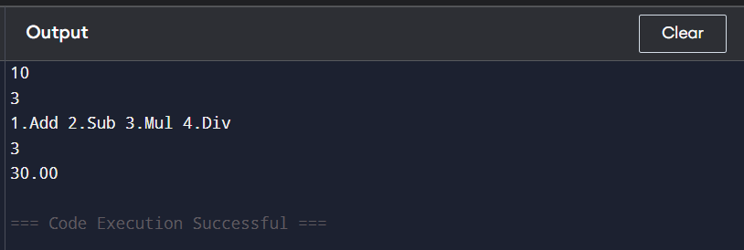

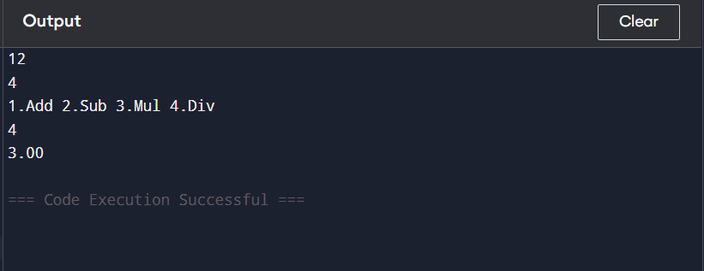

Assignment 3

Write a program in C to generate multiplication tables.

Program
#include <stdio.h>
int main() {
int n,i;
scanf("%d",&n);
for(i=1;i<=10;i++)
printf("%d x %d = %d\n",n,i,n*i);
return 0;
}

Output

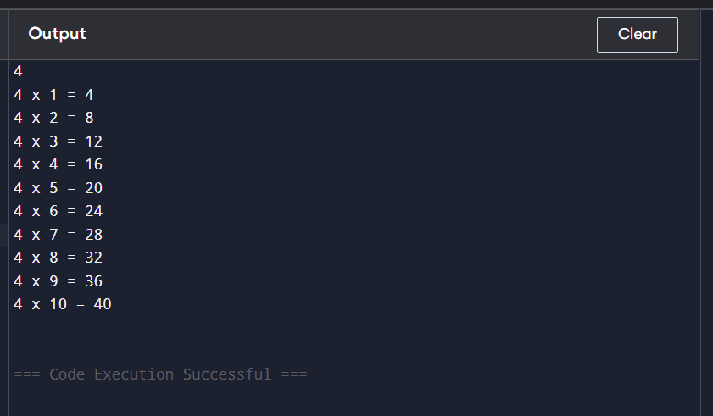

Assignment 4

Write a C Program to calculate the salary of an employee given his basic pay (taken as input from the user). Calculate gross salary of employee. Let HRA be 10 % of basic pay and TA be 5% of basic pay. Let employees pay professional tax as 2% of total salary. Calculate net salary payable after deductions.

Program

#include <stdio.h>
int main() {
float basic,hra,ta,gross,tax,net;
scanf("%f",&basic);
hra=0.10*basic;
ta=0.05*basic;
gross=basic+hra+ta;
tax=0.02*gross;
net=gross-tax;
printf("Net Salary: %.2f",net);
return 0;
}

Output

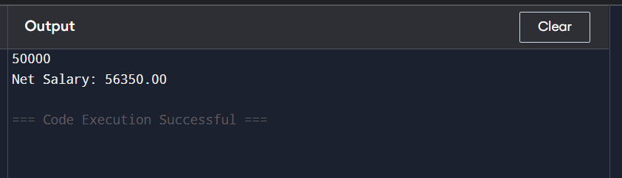

Assignment 5

Write a program in C to perform basic operations such as addition, saddle point, inverse, magic square of two matrices.

Program

#include <stdio.h>
int main() {
int a[2][2],b[2][2],c[2][2],i,j;
for(i=0;i<2;i++)
for(j=0;j<2;j++)
scanf("%d",&a[i][j]);
for(i=0;i<2;i++)
for(j=0;j<2;j++)
scanf("%d",&b[i][j]);
for(i=0;i<2;i++){
for(j=0;j<2;j++){
c[i][j]=a[i][j]+b[i][j];
printf("%d ",c[i][j]);
}
printf("\n");
}
return 0;
}

Output

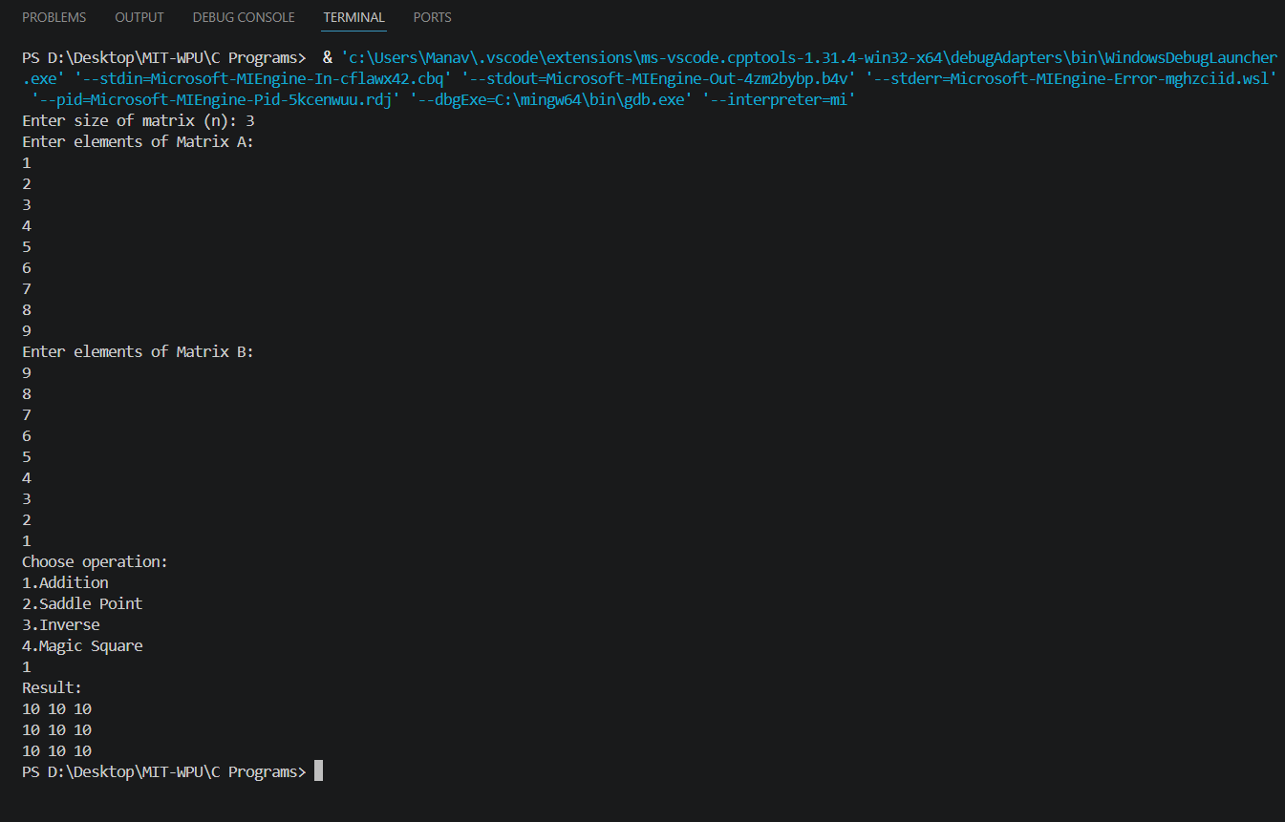

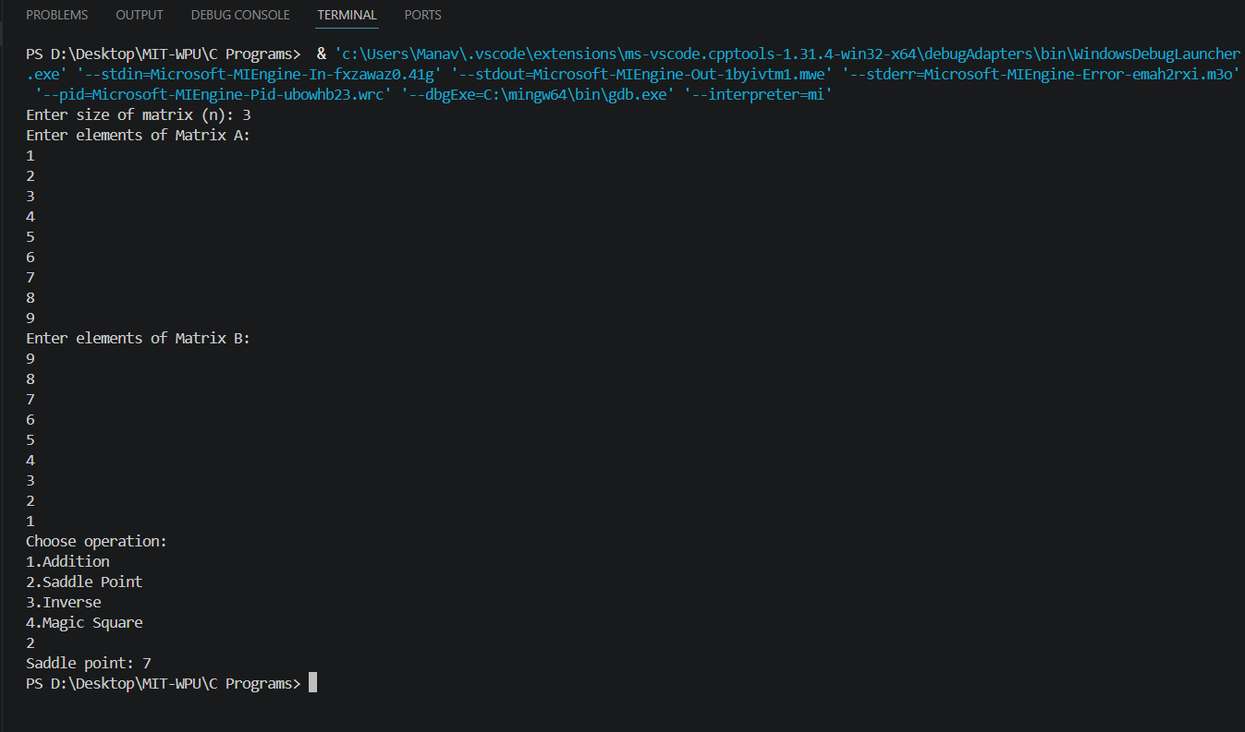

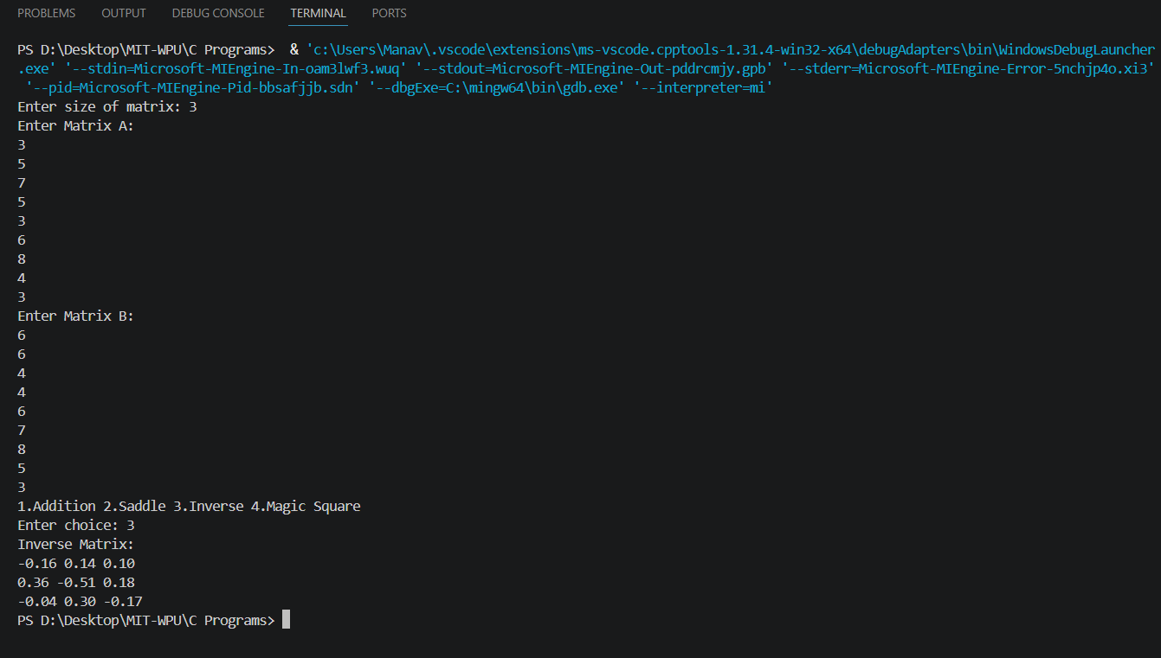

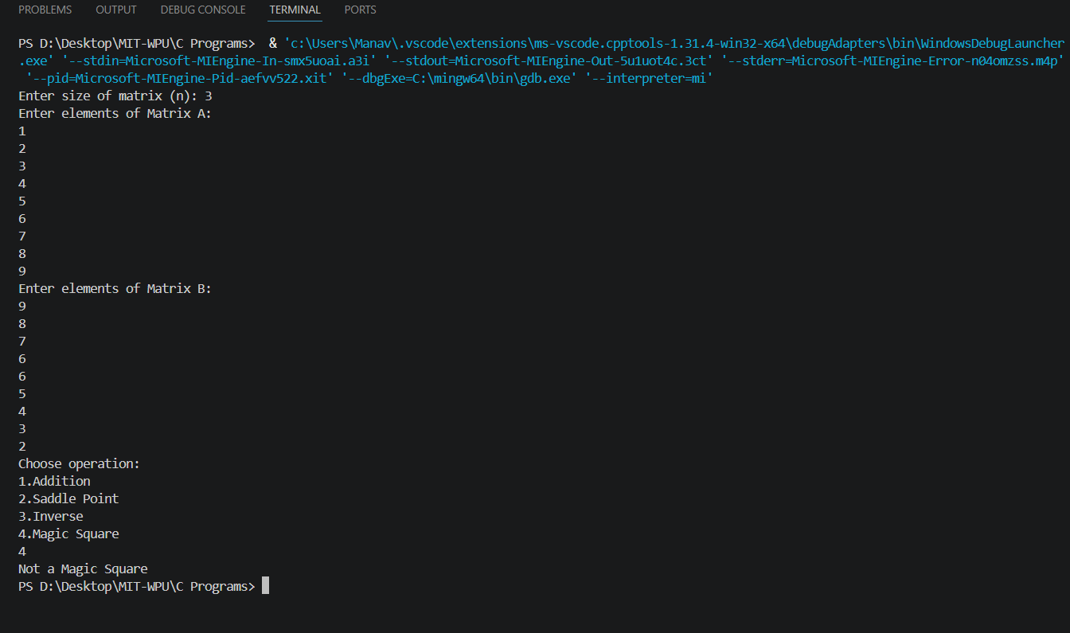

Assignment 6
Write a C function to compute the factorial of a number with and without recursion

Program (without recursion)

#include <stdio.h>

int main(){
int n,i,f=1;

printf("Enter number: ");
scanf("%d",&n);

for(i=1;i<=n;i++)
f*=i;

printf("Factorial: %d",f);

return 0;
}

Program (with recursion)

#include <stdio.h>

int fact(int n){
if(n==0)
return 1;
return n*fact(n-1);
}

int main(){
int n;

printf("Enter number: ");
scanf("%d",&n);

printf("Factorial: %d",fact(n));

return 0;
}

Output (without recursion)

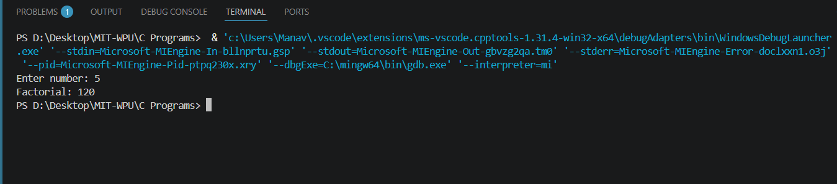

Output (with recursion)

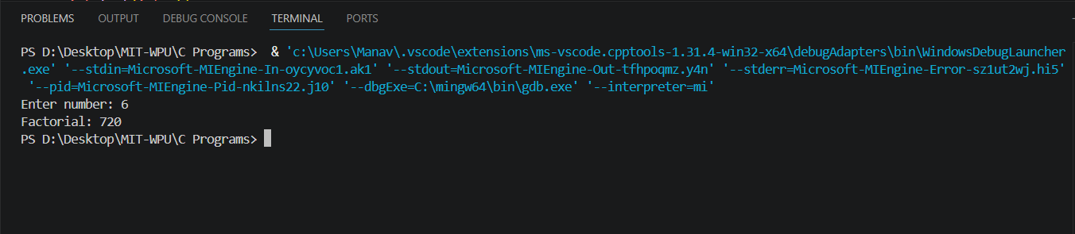

Assignment 7

Write a C program to accept student details and display their result using an array of structures.

Program

#include <stdio.h>

struct student{
int roll;
char name[20];
float m1, m2, m3, per;
};

int main(){
struct student s[3];
int i;

for(i=0;i<3;i++){
printf("Enter roll and name: ");
scanf("%d%s",&s[i].roll,s[i].name);

printf("Enter marks of 3 subjects: ");
scanf("%f%f%f",&s[i].m1,&s[i].m2,&s[i].m3);
}

printf("\nResults:\n");

for(i=0;i<3;i++){
printf("%d %s: ",s[i].roll,s[i].name);

if(s[i].m1<40 || s[i].m2<40 || s[i].m3<40){
printf("Fail\n");
}
else{
s[i].per = (s[i].m1 + s[i].m2 + s[i].m3)/3;

printf("Percentage: %.2f ",s[i].per);

if(s[i].per >= 80)
printf("Distinction");
else if(s[i].per >= 70)
printf("First Class");
else if(s[i].per >= 60)
printf("Second Class");
else
printf("Pass");

printf("\n");
}
}

return 0;
}

Output

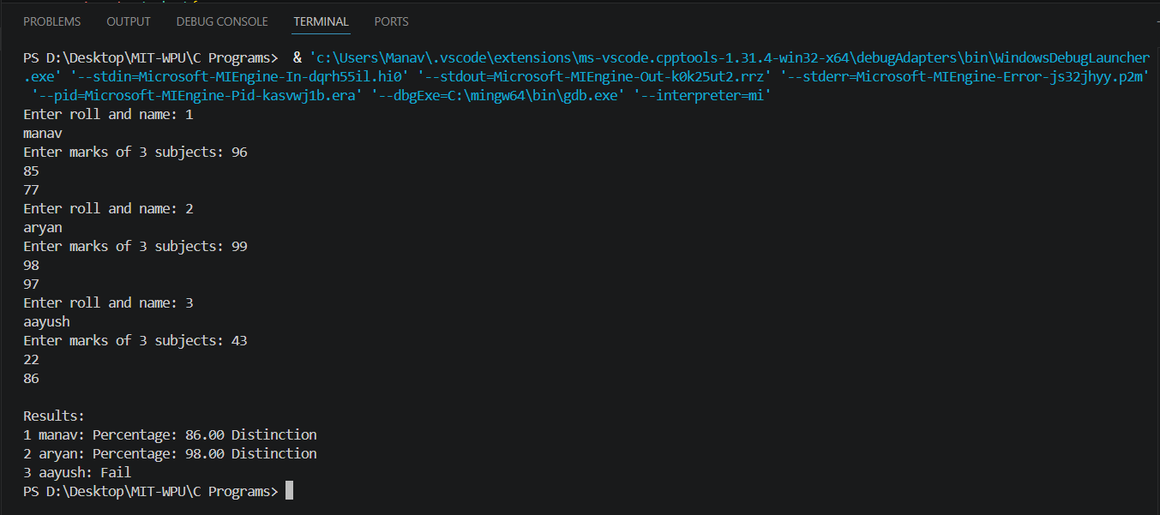

Assignment 8

To accept a student's five course marks and compute his/her result. Student is passing if he/she scores marks equal to and above 40 in each course. If student scores aggregate greater than 75%, then the grade is distinguished. If aggregate is 60>= and <75 then the grade of first division. If aggregate is 50>= and <60, then the grade is second division. If aggregate is 40>= and <50, then the grade is third division

Program

#include <stdio.h>
int main()
{
int m1,m2,m3,m4,m5,total;
float avg;
printf("Enter marks for 5 subjects: ");
scanf("%d%d%d%d%d",&m1,&m2,&m3,&m4,&m5);
if(m1<40||m2<40||m3<40||m4<40||m5<40)
{
printf("You have failed.");
}
else
{
total = m1+m2+m3+m4+m5;
avg = total/5;
if(avg >=75)
{
printf("Distinguished.");
}
else if(avg >=60 && avg <75)
{
printf("First Division.");
}
else if(avg >=50 && avg <60)
{
printf("Second Division.");
}
else if(avg >=40 && avg <50)
{
printf("Third Division.");
}
}
}

Output

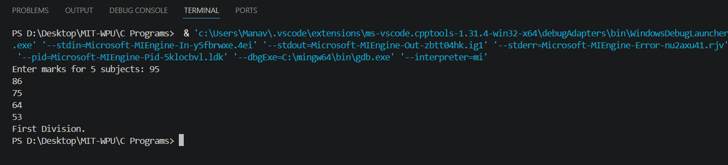

Assignment 9

To check whether the input number is Armstrong number or not. An Armstrong number is an integer with three digits such that the sum of the cubes of its digits is equal to the number itself. Ex. 371.

Program

#include <stdio.h>
int main()
{
int n,sum=0,a,temp;
printf("Enter number: ");
scanf("%d",&n);
temp = n;
while(temp!=0)
{
a = temp%10;
sum += a*a*a;
temp = temp/10;
}
if(sum == n)
{
printf("It is Armstrong number.");
}
else
{
printf("Not Armstrong Number.");
}
}

Output

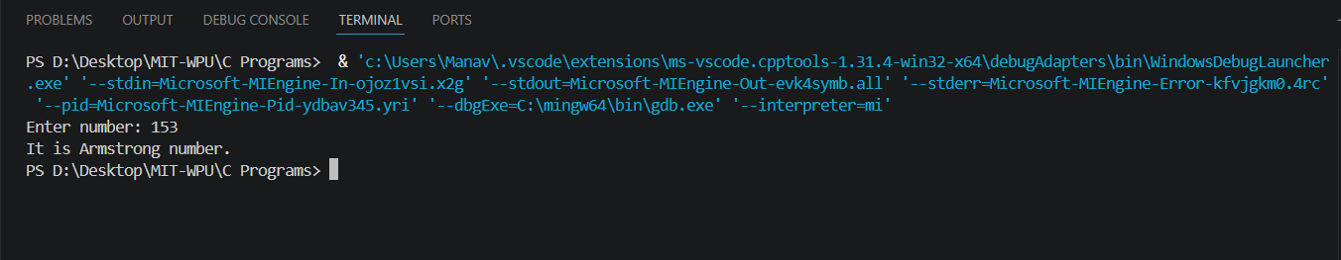

Assignment 10

To simulate a simple calculator that performs basic tasks such as addition, subtraction, multiplication and division with special operations like computing xy and x!

Program

#include <stdio.h>
#include <math.h>

int main(){
int ch,n,i,f=1;
float a,b;

printf("1.Add 2.Sub 3.Mul 4.Div 5.Power 6.Factorial\nEnter choice: ");
scanf("%d",&ch);

switch(ch){
case 1:
printf("Enter two numbers: ");
scanf("%f%f",&a,&b);
printf("%.2f",a+b);
break;

case 2:
printf("Enter two numbers: ");
scanf("%f%f",&a,&b);
printf("%.2f",a-b);
break;

case 3:
printf("Enter two numbers: ");
scanf("%f%f",&a,&b);
printf("%.2f",a*b);
break;

case 4:
printf("Enter two numbers: ");
scanf("%f%f",&a,&b);
printf("%.2f",a/b);
break;

case 5:
printf("Enter base and power: ");
scanf("%f%f",&a,&b);
printf("%.2f",pow(a,b));
break;

case 6:
printf("Enter number: ");
scanf("%d",&n);
for(i=1;i<=n;i++) f*=i;
printf("%d",f);
}

return 0;
}

Output

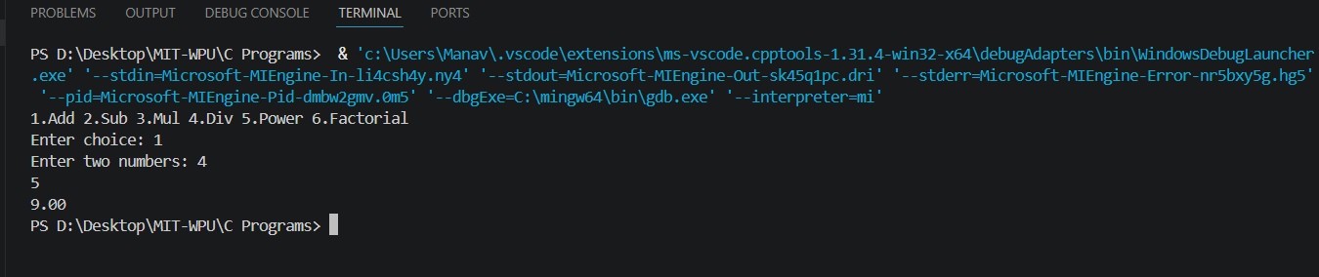
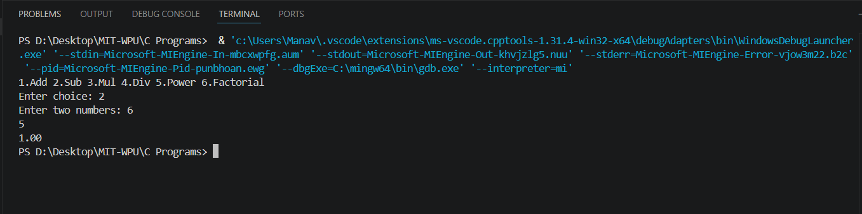
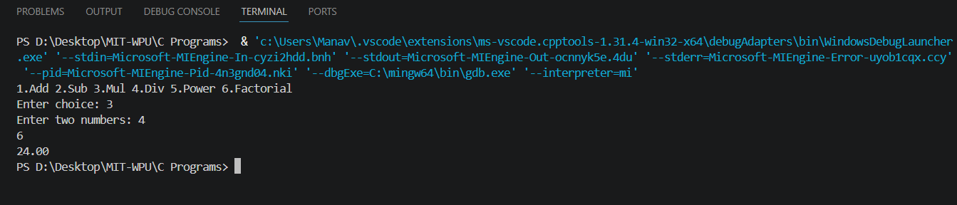
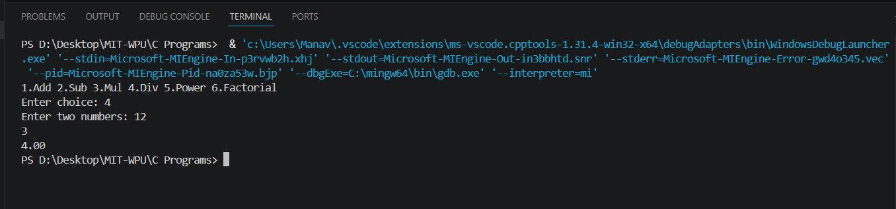
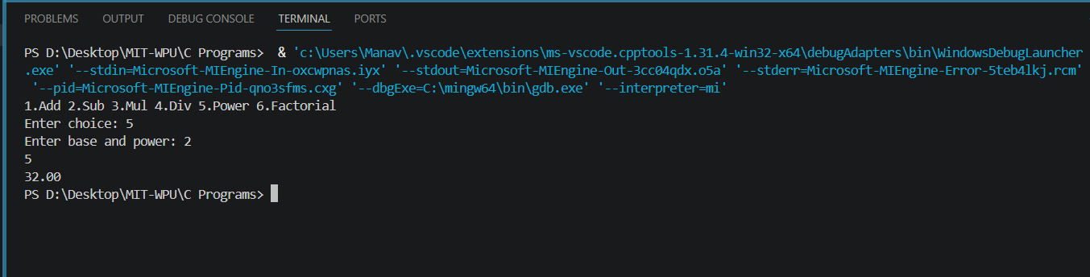
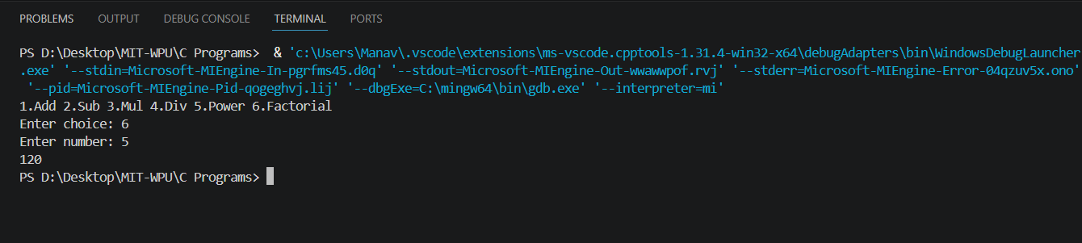

Assignment 11

To accept the number and Compute a) square root of number, b) Square of number, c) Cube of number d) check for prime, d) factorial of number e) prime factors

Program

#include <stdio.h>
#include <math.h>

int main(){
int n,i;

printf("Enter number: ");
scanf("%d",&n);

printf("Square root: %.2f\n",sqrt(n));
printf("Square: %d\n",n*n);
printf("Cube: %d\n",n*n*n);

int prime=1;
for(i=2;i<n;i++)
if(n%i==0) prime=0;

if(prime) printf("Prime\n");
else printf("Not Prime\n");

int f=1;
for(i=1;i<=n;i++) f*=i;
printf("Factorial: %d\n",f);

printf("Prime factors: ");
for(i=2;i<=n;i++)
if(n%i==0) printf("%d ",i);

return 0;
}

Output

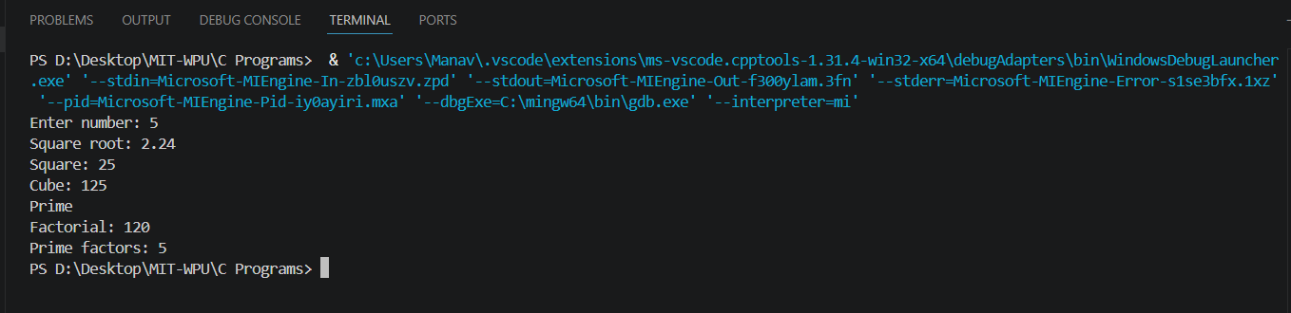

Assignment 12

To accept two numbers from user and compute smallest divisor and Greatest Common Divisor of these two numbers

Program

#include <stdio.h>

int main(){
int a,b,i,small_div=0,x,y;

printf("Enter two numbers: ");
scanf("%d%d",&a,&b);

// Smallest common divisor (greater than 1)
for(i=2;i<=a && i<=b;i++){
if(a%i==0 && b%i==0){
small_div=i;
break;
}
}

if(small_div==0)
printf("No common divisor other than 1\n");
else
printf("Smallest common divisor: %d\n",small_div);

// GCD using Euclidean algorithm
x=a; y=b;
while(y){
int t=y;
y=x%y;
x=t;
}

printf("GCD: %d",x);

return 0;
}

Output

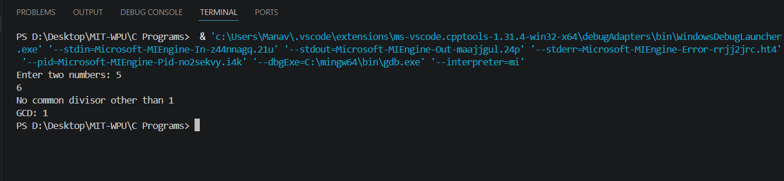
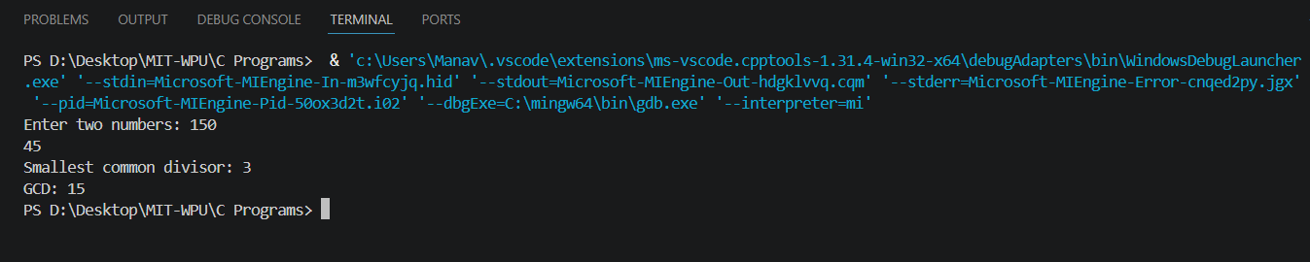

Assignment 13

To accept a number from user and print digits of number in a reverse order

Program

#include <stdio.h>
int main()
{
int num,rev=0;
scanf("%d",&num);
while(num!=0)
{
rev = rev*10 + num%10;
num=num/10;
}
printf("Reversed: %d",rev);
return 0;
}

Output

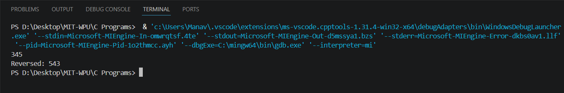

Assignment 14

To input binary number from user and convert it into decimal number

Program

#include <stdio.h>
#include <math.h>

int main(){
int n,r,i=0,dec=0;

printf("Enter binary number: ");
scanf("%d",&n);

while(n){
r=n%10;
dec+=r*pow(2,i);
n/=10;
i++;
}

printf("Decimal: %d",dec);

return 0;
}

Output

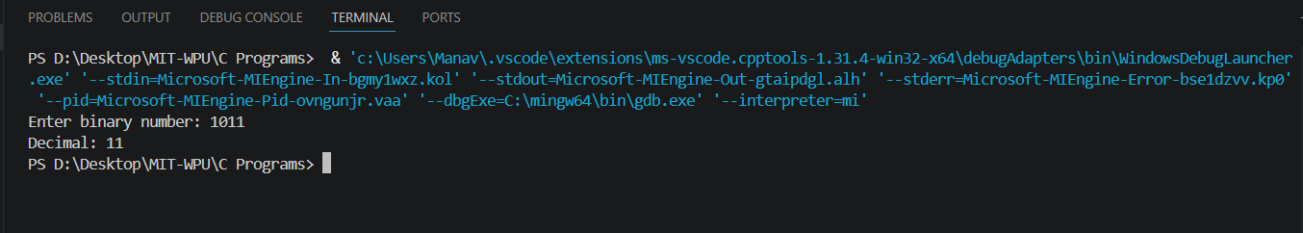

Assignment 15

To generate pseudo random numbers

Program

#include <stdio.h>
#include <stdlib.h>

int main(){
int i;

printf("Random numbers:\n");
for(i=0;i<5;i++)
printf("%d\n",rand());

return 0;
}

Output

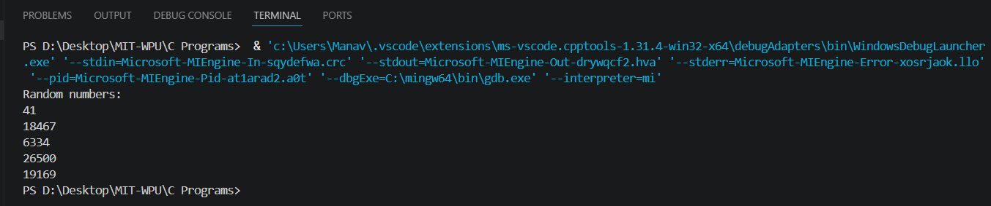

Assignment 16

To accept list of N integers and partition list into two sub lists even and odd numbers

Program

#include <stdio.h>

int main(){
int n,i,a[50];

printf("Enter number of elements: ");
scanf("%d",&n);

printf("Enter elements:\n");
for(i=0;i<n;i++) scanf("%d",&a[i]);

printf("Even: ");
for(i=0;i<n;i++)
if(a[i]%2==0) printf("%d ",a[i]);

printf("\nOdd: ");
for(i=0;i<n;i++)
if(a[i]%2!=0) printf("%d ",a[i]);

return 0;
}

Output

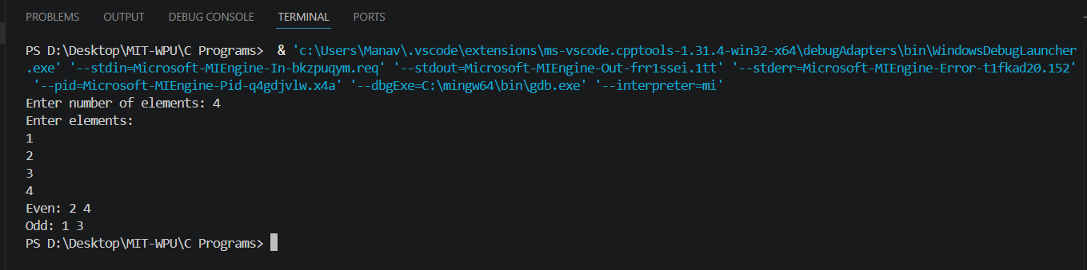

Assignment 17

To accept the number of terms a finds the sum of sine series

Program

#include <stdio.h>
#include <math.h>

int main(){
int n,i;
float x,sum=0;

printf("Enter value of x and terms: ");
scanf("%f%d",&x,&n);

for(i=1;i<=n;i++)
sum+=pow(-1,i-1)*pow(x,2*i-1)/tgamma(2*i);

printf("Sum: %.2f",sum);

return 0;
}

Output

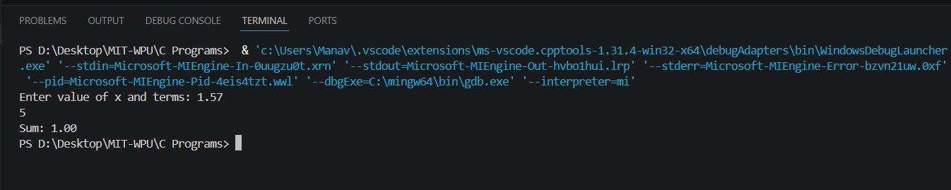

Assignment 18

Write a C program that accepts a string from user and perform following string operations- i. Calculate length of string ii. String reversal iii. Equality check of two strings iii. Check palindrome ii. Check substring

Program

#include <stdio.h>
#include <string.h>

int main(){
char a[50], b[50], temp[50];

printf("Enter first string: ");
scanf("%s", a);

printf("Enter second string: ");
scanf("%s", b);

// Length
printf("Length: %lu\n", strlen(a));

// Reverse
strcpy(temp, a);
strrev(temp);
printf("Reverse: %s\n", temp);

// Equality
if(strcmp(a, b) == 0)
printf("Equal: Yes\n");
else
printf("Equal: No\n");

// Palindrome
strcpy(temp, a);
strrev(temp);
if(strcmp(a, temp) == 0)
printf("Palindrome\n");
else
printf("Not Palindrome\n");

// Substring
if(strstr(a, b))
printf("Substring found\n");
else
printf("Substring not found\n");

return 0;
}
Output

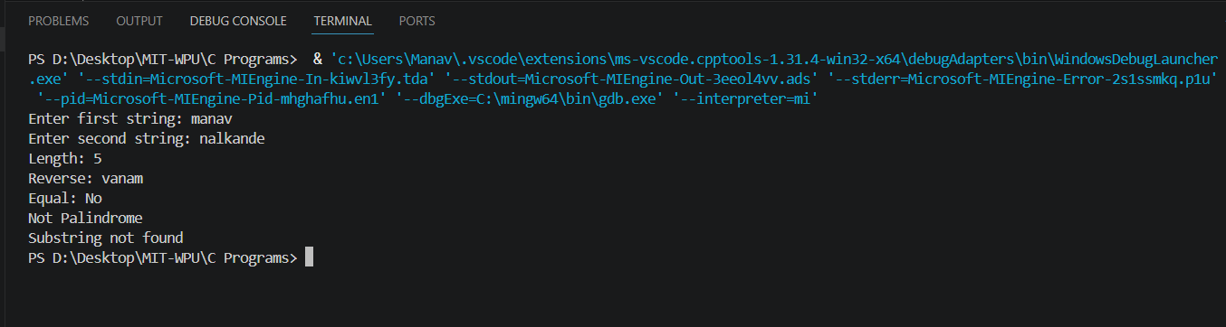

Assignment 19

Create Structure EMPLOYEE for storing details (Name, Designation, gender, Date of Joining and Salary). Define function members to compute a) total number of employees in an organization b) count of male and female employee c) Employee with salary more than 10,000 d) Employee with designation “Asst Manager

Program

#include <stdio.h>
#include <string.h>

struct emp{
char name[20], des[30], gen;
float sal;
};

int main(){
struct emp e[3];
int i, m=0, f=0;

for(i=0;i<3;i++){
printf("Enter name: ");
scanf("%s", e[i].name);

printf("Enter designation (use underscore e.g. Asst_Manager): ");
scanf("%s", e[i].des);

printf("Enter gender (M/F): ");
scanf(" %c", &e[i].gen);

printf("Enter salary: ");
scanf("%f", &e[i].sal);
}

printf("\nEmployees with salary > 10000:\n");
for(i=0;i<3;i++){
if(e[i].sal > 10000)
printf("%s\n", e[i].name);
}

printf("\nEmployees with designation Asst_Manager:\n");
for(i=0;i<3;i++){
if(strcmp(e[i].des,"Asst_Manager")==0)
printf("%s\n", e[i].name);
}

for(i=0;i<3;i++){
if(e[i].gen=='M') m++;
else if(e[i].gen=='F') f++;
}

printf("\nTotal: %d Male: %d Female: %d",3,m,f);

return 0;
}
Output

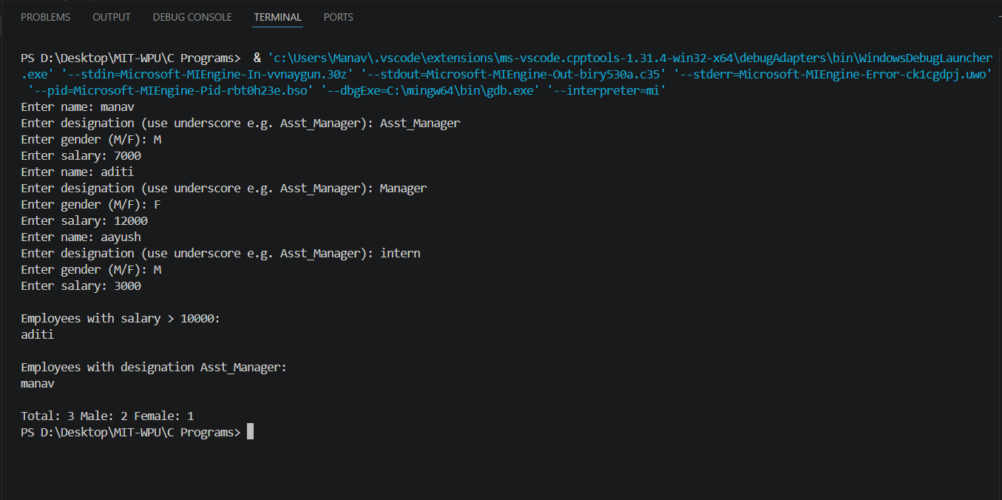

Assignment 20

Swaping of two numbers using 2 methods
- Using of pointers
- Without using pointers

#include <stdio.h>

// Without pointers
void sw1(int a, int b) {
int t;
t = a;
a = b;
b = t;
printf("After swap (without pointers): %d %d\n", a, b);
}

// With pointers
void sw2(int *a, int *b) {
int t;
t = *a;
*a = *b;
*b = t;
}

int main() {
int x, y;

scanf("%d %d", &x, &y);

sw1(x, y); // No actual swap in main
sw2(&x, &y); // Actual swap using pointers

printf("After swap (with pointers): %d %d\n", x, y);

return 0;
}

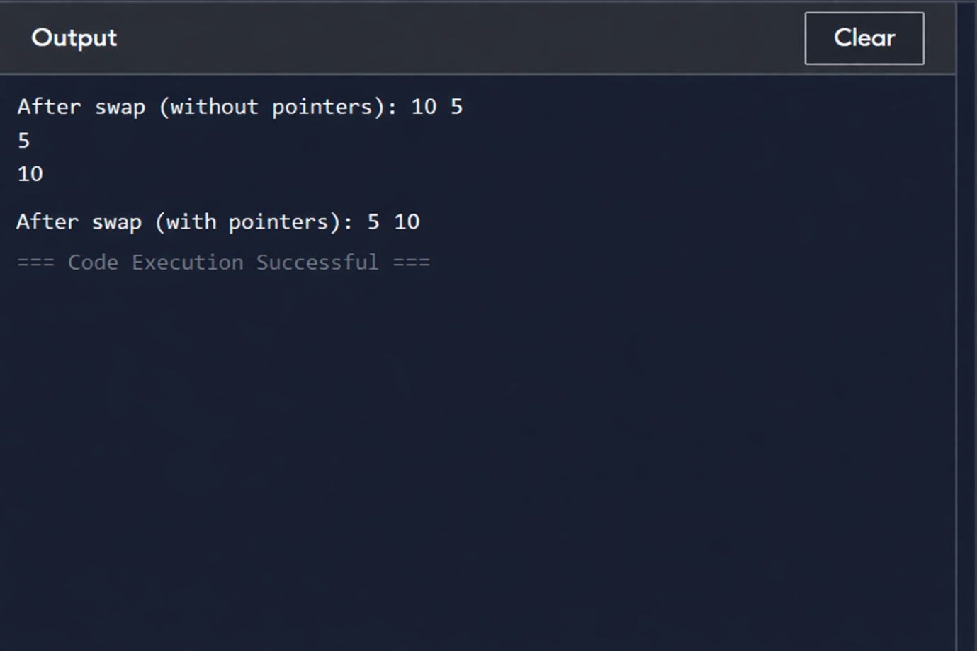

Assignment 21

Write a program to copy contents of one file to another using C programming language

#include <stdio.h>

int main() {
FILE *f1, *f2;
char c;

f1 = fopen("source.txt", "r");
if (f1 == NULL) {
printf("Error opening source file\n");
return 1;
}

f2 = fopen("destination.txt", "w");
if (f2 == NULL) {
printf("Error opening destination file\n");
fclose(f1);
return 1;
}

while ((c = fgetc(f1)) != EOF) {
fputc(c, f2);
}

printf("File copied successfully\n");

fclose(f1);
fclose(f2);

return 0;
}

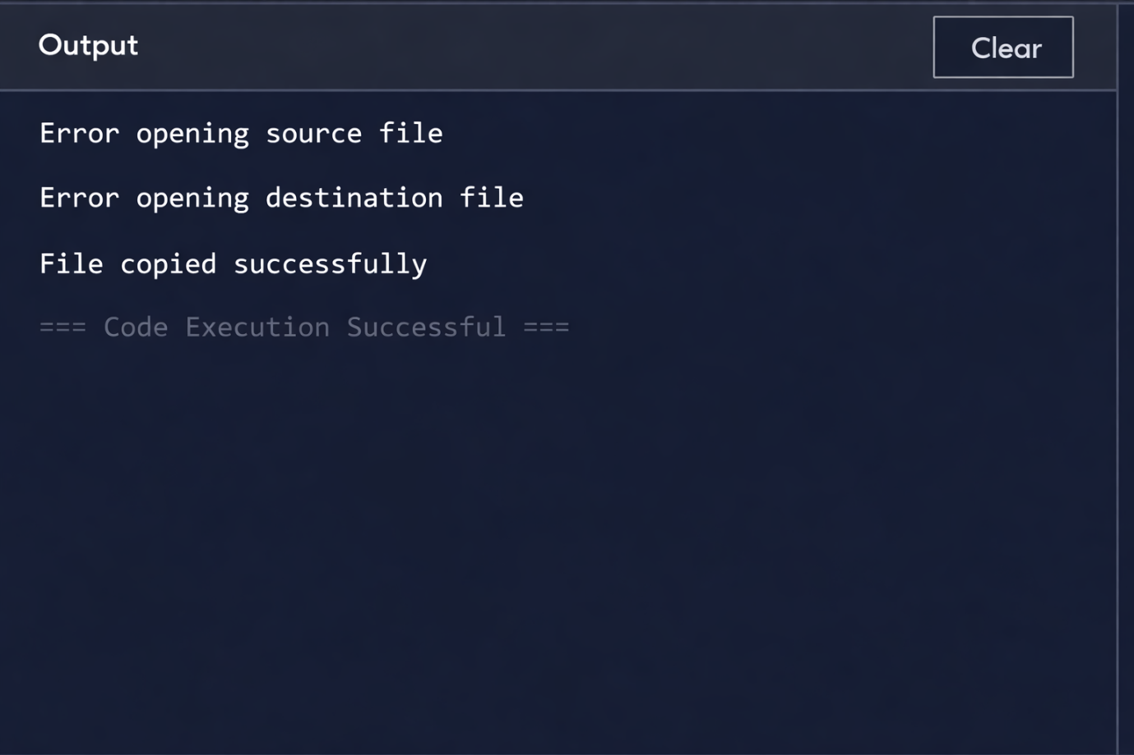

Assignment 22

Write a program in C programming to perform menu driven program in C to perform various string operations

#include <stdio.h>
#include <string.h>

// custom strrev function
void strrev(char *str) {
int i, j;
char temp;
int len = strlen(str);

for(i = 0, j = len - 1; i < j; i++, j--) {
temp = str[i];
str[i] = str[j];
str[j] = temp;
}
}

int main() {
char a[100], b[100];
int ch;

do {
printf("\n1. Length\n2. Copy\n3. Concatenate\n4. Compare\n5. Reverse\n6. Exit\n");
scanf("%d", &ch);

switch(ch) {
case 1:
printf("Enter string: ");
scanf("%s", a);
printf("Length = %lu\n", strlen(a));
break;

case 2:
printf("Enter string: ");
scanf("%s", a);
strcpy(b, a);
printf("Copied string = %s\n", b);
break;

case 3:
printf("Enter first string: ");
scanf("%s", a);
printf("Enter second string: ");
scanf("%s", b);
strcat(a, b);
printf("Concatenated string = %s\n", a);
break;

case 4:
printf("Enter first string: ");
scanf("%s", a);
printf("Enter second string: ");
scanf("%s", b);
if(strcmp(a, b) == 0)
printf("Strings are equal\n");
else
printf("Strings are not equal\n");
break;

case 5:
printf("Enter string: ");
scanf("%s", a);
strrev(a); // now works
printf("Reversed string = %s\n", a);
break;

case 6:
break;

default:
printf("Invalid choice\n");
}
} while(ch != 6);

return 0;
}

